**The Database Development and Class Registration**

Be Huynh

University of Arizona Global Campus

CST499: Capstone for Computer Software Technology

Professor Joseph Rangitsch

February 24, 2025

### **Introduction**

This assignment was focused on creating a class registration system. I worked on setting up a database and making sure everything worked properly. The main goal was to allow students to register for classes, manage their schedules, and join waitlists if needed. I created MySQL tables to store data, connected them to the website, and added important features like login and class registration.

**Create your tables within the MySQL database related to rest of your design.**

All the necessary tables were created at the beginning. The classes table lists all available classes with details. The students table stores student information, including login details. The registrations table links students to their enrolled classes. The waitlist table keeps track of students waiting for a class.

**Create the different pages related to the rest of the requirements and the design per your work in Week 1 and Week 2.**

After registration and login, the last page to create was the student portal page. This page lets students sign up for classes. If a class is full, they are added to the waitlist. If there is space, they are enrolled, and the student counts updates. When a student drops a class, they are removed, and the student count adjusts. If there are students on the waitlist, the next one in line gets enrolled, and the waitlist updates. If a student leaves the waitlist, they are removed, and the list shifts to fill the gap.

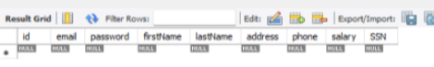







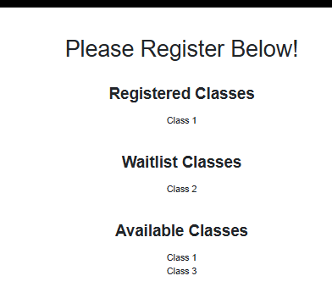

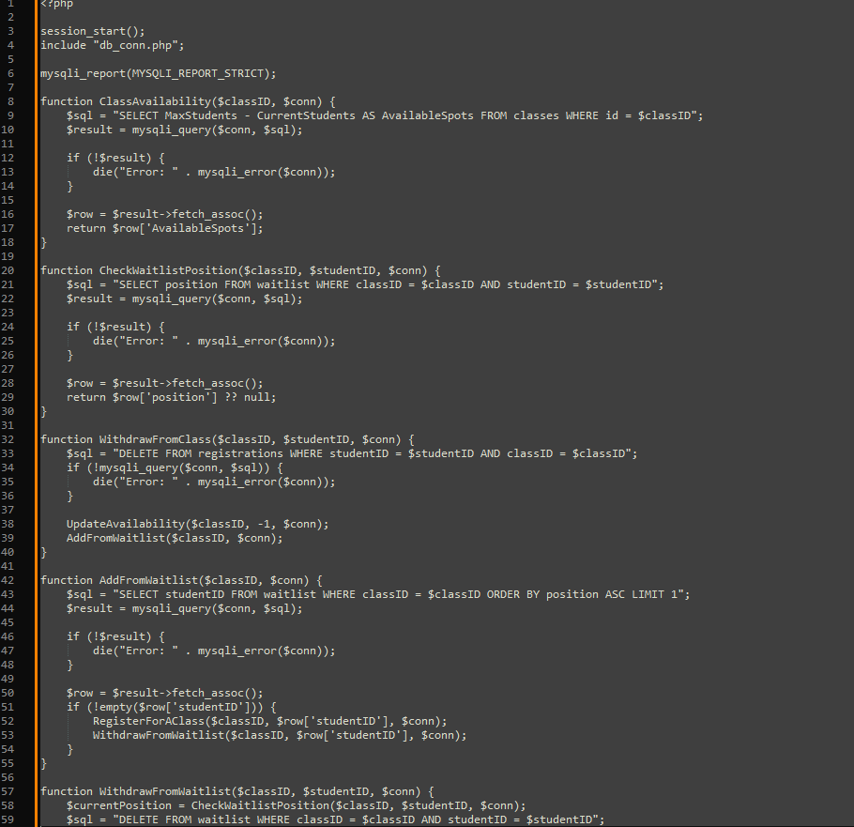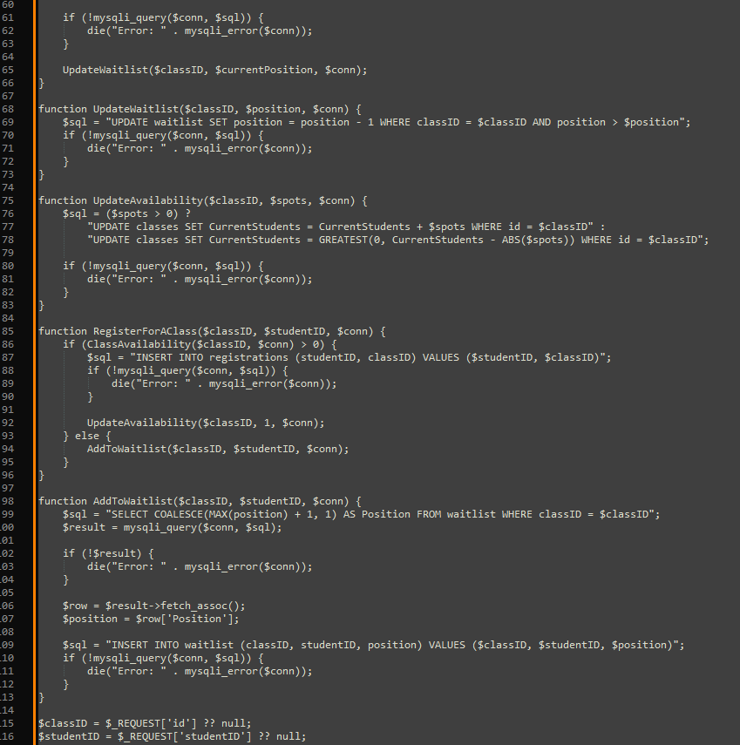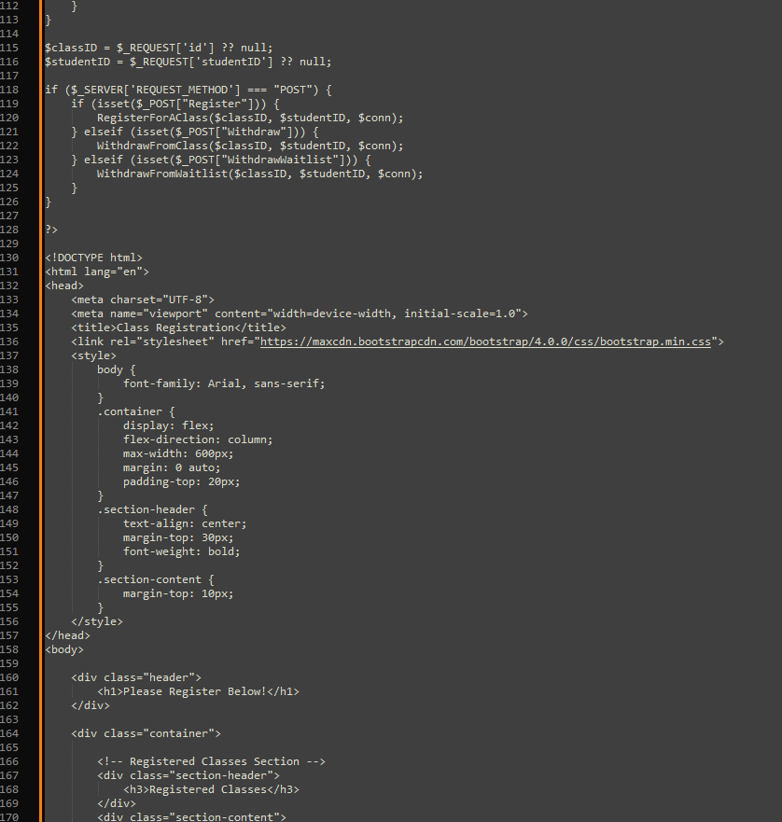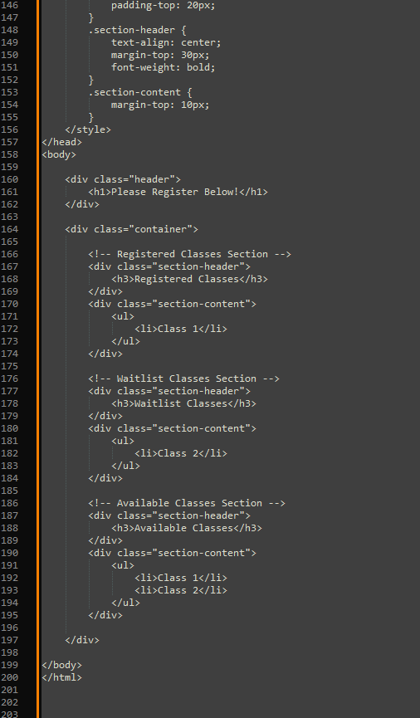

**login**

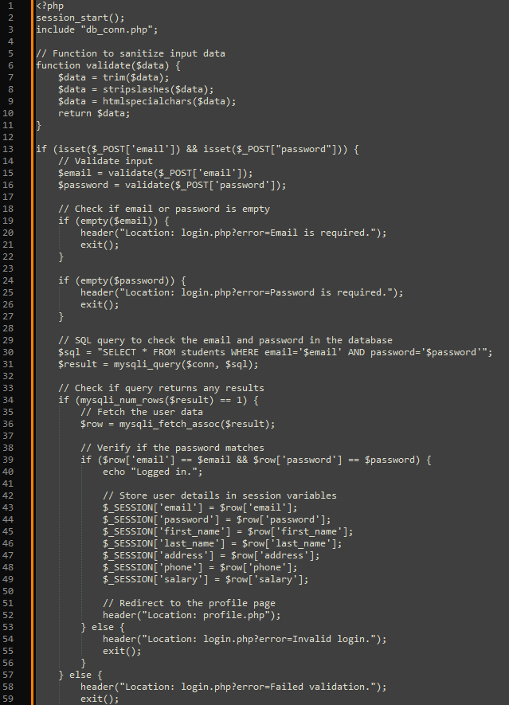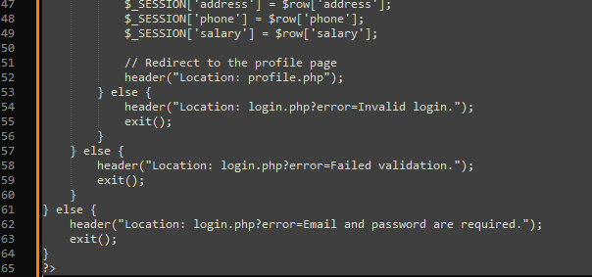

**Profile**

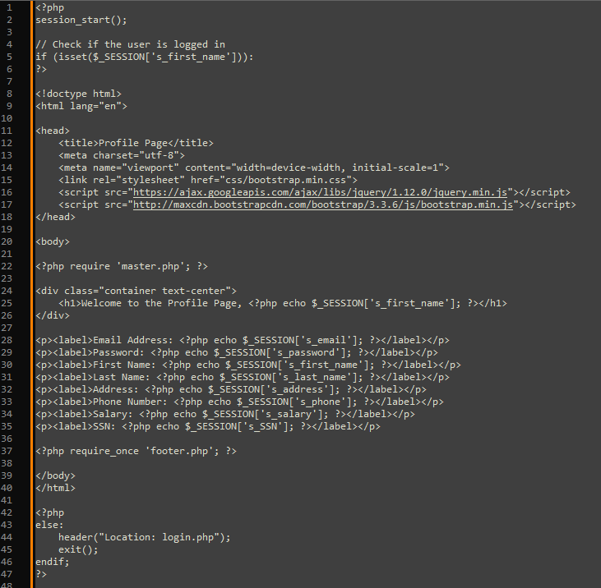

**Student Portal**

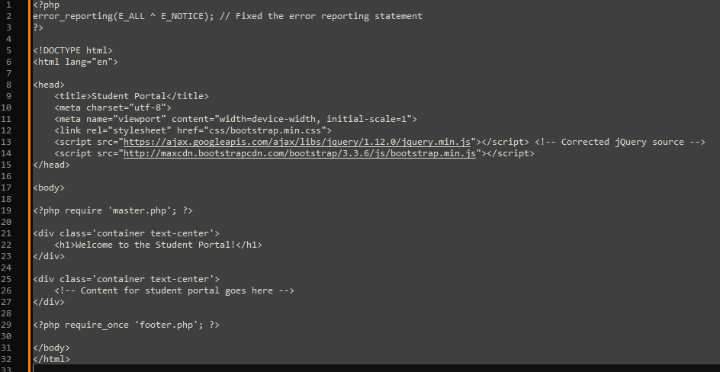

**Logout**

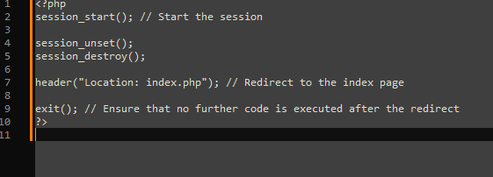

**Summarize your experience going through the implementation phase.**

The implementation phase was a good learning experience. I started by creating the database tables and linking them to the website. Then, I set up the registration and login features so students could use the system. The Student Portal page was important because it let students sign up for classes, join waitlists, and drop classes. I tested it to make sure everything was updated correctly in the database. There were some challenges, like fixing database connection errors and making sure the pages showed the right information. Debugging took a lot of time, but it helped me understand MySQL and PHP better. Overall, it was great to see everything work. These assignments helped me learn how to build a system and use databases.

**Conclusion**

This assignment was a valuable learning experience. It helped me improve my skills in using MySQL and PHP. While working on the system, I faced some challenges, like fixing errors and making sure the data updated correctly, but solving these problems made the project more rewarding. In the end, seeing the system work as expected boosted my confidence in building functional and useful systems.

**References**

GeeksforGeeks. (2024, June 5). *How to Insert Form Data into Database using PHP ?* GeeksforGeeks. https://www.geeksforgeeks.org/how-to-insert-form-data-into-database-using-php/

GeeksforGeeks. (2020, November 2). *PHP Database connection*. GeeksforGeeks. https://www.geeksforgeeks.org/php-database-connection/

Hosting, S. W. (2021, August 17). *PhpMyAdmin Database Management Tutorial*. SiteGround. https://www.siteground.com/tutorials/phpmyadmin/database-management/

Menon, K. (2024, July 10). *PHP with MySQL: Ultimate Step-By-Step Guide*. Simplilearn.com. https://www.simplilearn.com/tutorials/php-tutorial/php-with-sql

Tsui, F., Karam, O., & Bernal, B. (2018). Essentials of software engineering (4th ed.). Jones & Bartlett Learning.

**Landing, Login, and Enrollment Pages Development**

Be Huynh

University of Arizona Global Campus

CST499: Capstone for Computer Software Technology

Professor Joseph Rangitsch

February 17, 2025

**Introduction**

Running PHP files in XAMPP is a simple way to build and test web applications on your computer. XAMPP includes Apache, MySQL, and PHP, making it easy to run PHP projects. In this guide, I'll show you how to set up PHP, create a registration page for new users, and save their information in a MySQL database. I will also explain how to create a custom class to manage the database connection.

**How to Run a PHP File in XAMPP**

To run a PHP file in XAMPP, the first step is to download and install XAMPP from its official website. Once installed, open the XAMPP Control Panel and start both the Apache and MySQL services. These services are necessary to run PHP and interact with the database. Next, create a PHP file using a text editor like Notepad++ or Visual Studio Code, and save it with a .php extension (e.g., index.php). After that, move the file to the htdocs folder in the XAMPP directory. To see your file in action, open a web browser and go to http://localhost/index.php.

**Create the landing page, login page, and registration page for new users.**



**Discuss the MySQL database functions that you used and the steps you took to create the database connection custom class.**

To connect PHP to a MySQL database, use the mysqli_connect() function. This function requires the database server (usually localhost), the username (often root), the password, and the database name. The connection is stored in a variable like $conn, which you can later use to perform database operations. If the connection fails, an error message will be shown. You can also create a custom class to handle database connections, making your code more organized and reusable. This class can include methods to open the connection, close it, and run queries, making it easier to maintain your code.

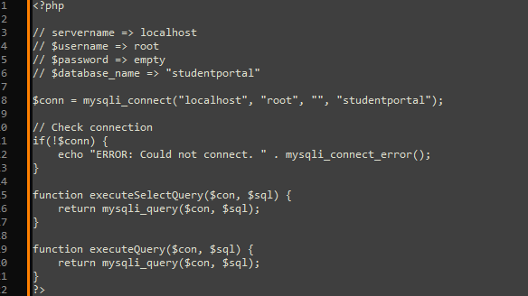

**Develop the registration page layout.**

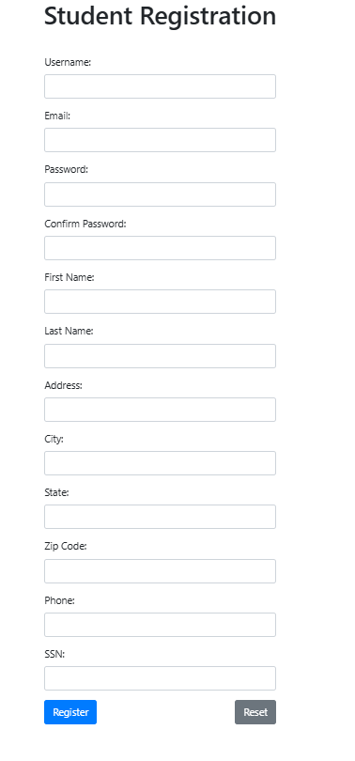

**Develop the registration page PHP source code.**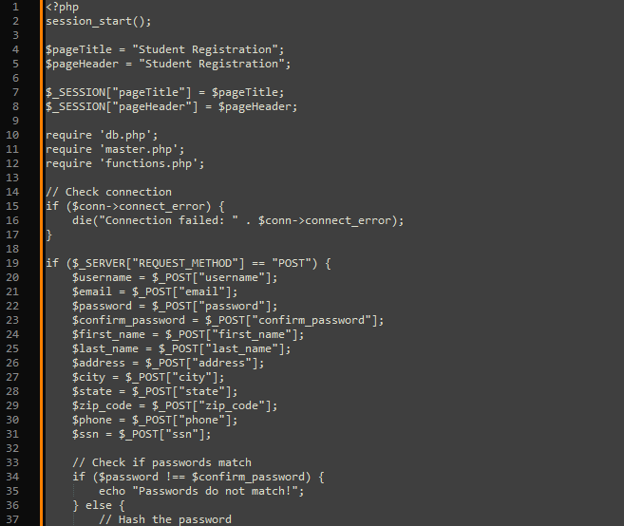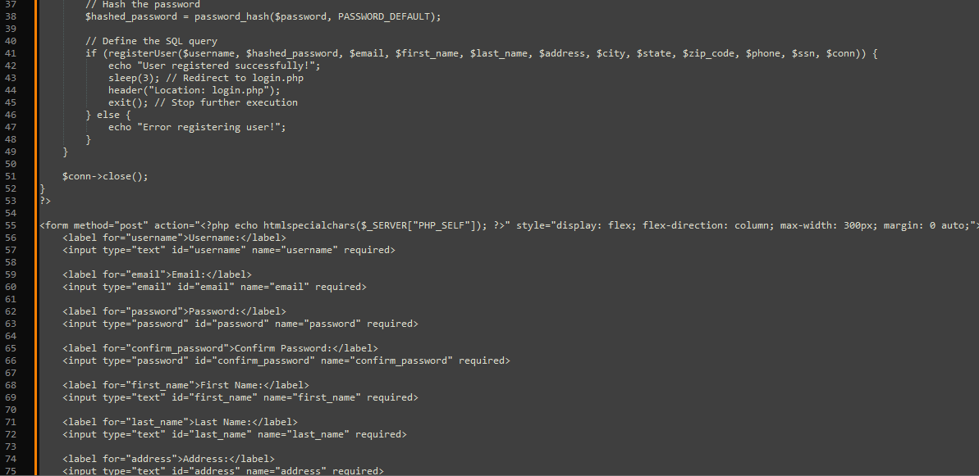

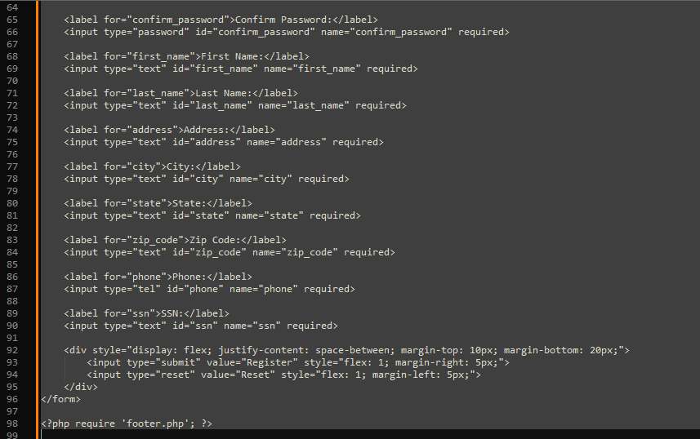

**Develop the table that saves the user information in the database.**



**Explain the steps taken to create the registration page and save the user information in the database.**

The first step involved creating a form on the registration page to send data to the insert.php page. The form includes labels and input fields for each required piece of information, along with a submit button. Upon clicking the submit button, the form data is sent to insert.php. The script connects to the database, assigns the submitted values to variables, and then inserts those values into the database.

**Provide screenshots of all developed pages, database, tables, layout, and source code.**



**login**



**Profile**



**Student Portal**



**Logout**



**Conclusion**

In conclusion, setting up PHP in XAMPP and developing a registration system was both challenging and a valuable learning experience. Although building the pages and saving user data in MySQL took time and caused some confusion along the way, the process was ultimately rewarding. By utilizing mysqli_connect() and creating a custom class for database connections, I gained a deeper understanding of working with databases. While it was a tough task, it was a great opportunity to grow and improve my skills as a developer.

**References**

GeeksforGeeks. (2024, June 5). *How to Insert Form Data into Database using PHP ?* GeeksforGeeks. https://www.geeksforgeeks.org/how-to-insert-form-data-into-database-using-php/

Hosting, S. W. (2021, August 17). *PhpMyAdmin Database Management Tutorial*. SiteGround. https://www.siteground.com/tutorials/phpmyadmin/database-management/

Tsui, F., Karam, O., & Bernal, B. (2018). Essentials of software engineering (4th ed.). Jones & Bartlett Learning.